CSA1505-Cloud computing and big data analytics
5-Office Time Off
The Office Time-Off Management System in Zoho Creator simplifies employee leave requests, approvals, and tracking. It allows employees to submit time-off requests online, stores records securely in the cloud, reduces paperwork, improves transparency, maintains accurate leave records, and generates reports for efficient attendance management.
INPUT
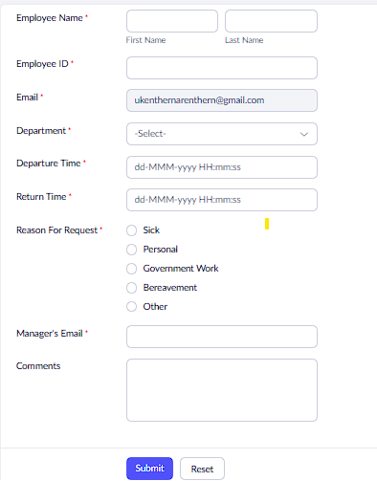

OUTPUT

